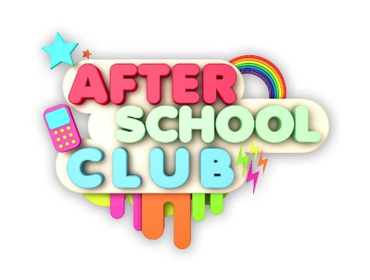

|  |  |  |  |  |  |
| --- | --- | --- | --- | --- | --- |
| **Crossflatts Primary After School Club Registration Form** | | | | | |
| Childs Full Name |  | | | | |
| Preferred Name |  | | | | |
| Address |  | | | | |
| Date of birth |  | | | | |
| Class and year group |  | | | | |
| Parents/carers name |  | | | | |
| Address |  | | | | |
| Telephone – home |  | | | | |
| Work |  | | | | |
| Mobile |  | | | | |
| Email Address |  | | | | |
| Which days do you require (please tick) | Mon | Tue | Wed | Thur | Fri |
|  |  |  |  |  |
| When would you like to start |  | | | | |
| Second contact (in case of emergency) |  | | | | |
| Second contact Telephone Number |  | | | | |
| Does your child have any medical conditions? |  | | | | |
| Please list all adults who may collect your child and their relationship to your child: |  | | | | |
| Does your child have any food allergies? |  | | | | |
| Any Further information you would like to share |  | | | | |
| **Please read the following statements and complete the consent** | | | | | |
| I agree to inform ASC if my child will not attend due to illness holiday, or other engagement by directly contacting the club by call or text |  | | | | |
| I understand that if my child does not attend the club that this will still be paid for unless a school residential or a whole school closure. |  | | | | |
| I will provide sunscreen for my child to use at after school club |  | | | | |
| I understand that if I am late to collect my child there is a fee of £5 after 5:50pm. If school could not contact an adult beyond 6.15, they would follow safeguarding procedures in line with school policy, unless parent/carers have contacted the club and made arrangements |  | | | | |
| I give permission for my child’s photo to be used in displays or on the school website at the club |  | | | | |
| I will advise ASC of any changes to my child’s details as advised on this application form |  | | | | |
| I consent to my child being given first aid treatment in the event of an accident or illness |  | | | | |
| **Payment must be paid monthly in advance by the 10th of each month. Failure to pay, will result in you losing your place at after school club. By completing this form you consent to these terms of payment.** | | | | | |

Parent/carer signature _________________________

Date ______________________________